**Sukuna Multiple Campus**

Name: **SANAM TAMANG**

Symbol no: 76214020

Subject: OOP with C++

Submitted To: Uma Dhungel

//Encapsulation

#include <iostream>

#include <conio.h>

using namespace std;

class StudentInfo{

private:

string name,address;

int rollno;

public:

void setData(string name,string address,int rollno){

this->name=name;

this->address=address;

this->rollno=rollno;

}

void getData(){

cout<<"Name: "<<name<<endl;

cout<<"Address: "<<address<<endl;

cout<<"Rollno: "<<rollno<<endl;

}

};

int main(){

StudentInfo student1;

student1.setData("Sanam Tamang","Sundarharaincha-12",14);

student1.getData();

return 0;

}

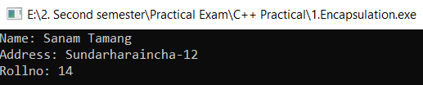

//Outside of class

#include <iostream>

#include <conio.h>

using namespace std;

class WorkersInfo{

string name,address;

string phoneno;

public:

void setData(string name,string address,string phoneno){

this->name=name;

this->address=address;

this->phoneno=phoneno;

}

string getName();

string getAddress();

string getPhoneno();

};

string WorkersInfo::getName(){

return name;

}

string WorkersInfo::getAddress(){

return address;

}

string WorkersInfo::getPhoneno(){

return phoneno;

}

int main(){

WorkersInfo worker1;

worker1.setData("Hari Bahadur","Sundarharaincha-12","9812345678");

cout<<"Name: "<<worker1.getName()<<endl;

cout<<"Address: "<<worker1.getAddress()<<endl;

cout<<"Phoneno: "<<worker1.getPhoneno()<<endl;

}

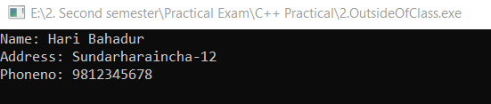

//Single Inheritance

#include <iostream>

#include <conio.h>

using namespace std;

class Information{

protected:

string name;

int age;

};

class Worker:public Information{

public:

void setData(){

cout<<"Enter your name: ";

cin>>name;

cout<<"Enter your age: ";

cin>>age;

}

void getData(){

cout<<"Name: "<<name<<endl;

cout<<"Age" <<age;

}

};

int main(){

Worker worker;

worker.setData();

worker.getData();

}



//Multiplication of two numbers

#include <iostream>

#include <conio.h>

using namespace std;

class Multiplication{

int a,b,mul;

public:

void setData(){

cout<<"Enter two numbers ";

cin>>a>>b;

}

void getData(){

mul=a*b;

cout<<"Multiplication of "<<a<<" and "<<b<<" is "<<mul;

}

};

int main(){

Multiplication multiplication;

multiplication.setData();

multiplication.getData();

}

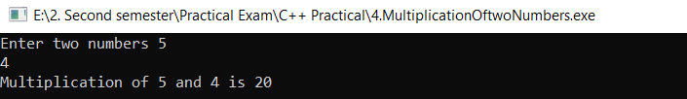

//Unary Operator overloading

#include <iostream>

#include <conio.h>

using namespace std;

class Counter{

int count;

public:

Counter(){

count=0;

}

void operator++(){

++count;

}

void getData(){

cout<<"Number is: "<<count<<endl;

}

};

int main(){

Counter count;

count.getData();

++count;

++count;

count.getData();

}

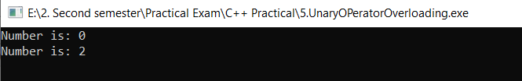

//Parameterize constructor

#include <iostream>

#include <conio.h>

using namespace std;

class Car{

string nameOfCar,address;

double price;

public:

Car(string nameOfCar,string address,double price){

this->nameOfCar=nameOfCar;

this->address=address;

this->price=price;

}

void getData(){

cout<<"Car Name: "<<nameOfCar<<endl;

cout<<"Address: "<<address<<endl;

cout<<"Price: $"<<price<<endl;

}

};

int main(){

Car car("Telsa","United State",100000);

car.getData();

return 0;

}

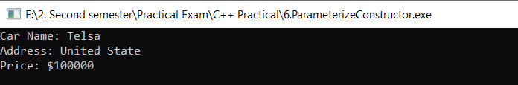

//Destructor

#include <iostream>

#include <conio.h>

using namespace std;

class Information{

public:

Information(){

cout<<"Constructor is called ";

}

~Information(){

cout<<endl<<"Destrutor is called ";

}

};

int main(){

Information info;

return 0;

}

